(Updated 11/7/16)
MyMITC User Guide

- To access MyMITC, visit www.tcle.org & click on “Employee Resources” in the far, right-hand column
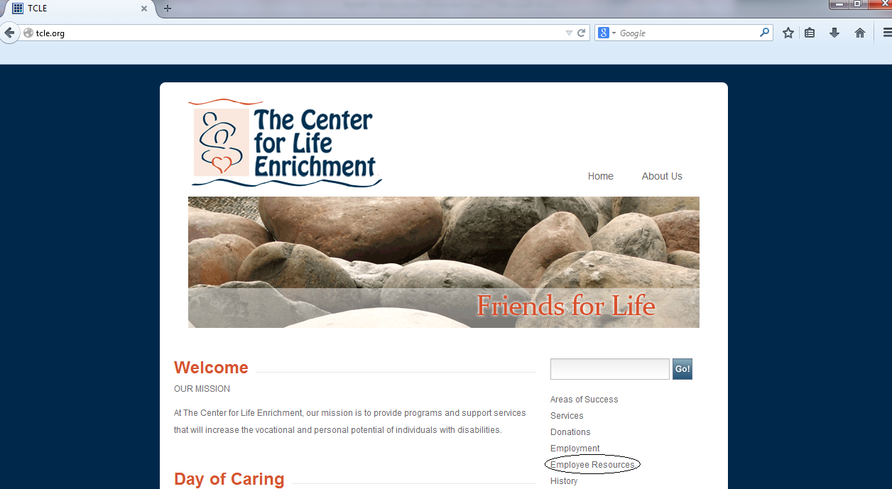

- Once on the “Employee Resources” page, click the link that says “Click to log on to MyMITC”
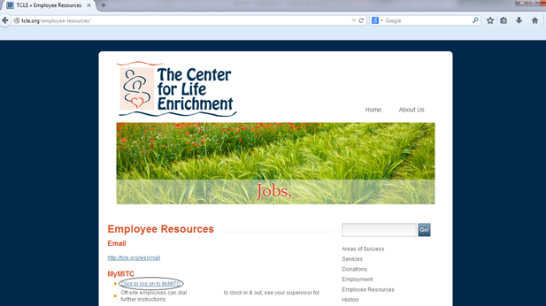

- Insert User Name and Password initially given to you by TCLE; typically, the initial username & password will be your employee ID number. Click Logon. Once entered, you will be immediately prompted to change your username and password (password must be at least 6 digits, only numbers or letters can be used; no symbols). Once a new username and password are created, you must log out and log back in using your newly created username and password.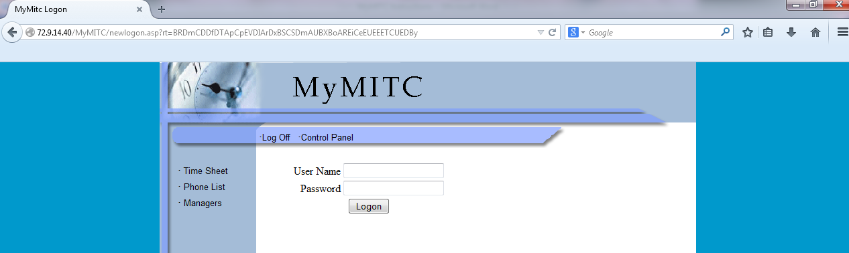
- Once you are logged-in with your newly created username and password, click on “Time Sheet” in the far, left-hand column
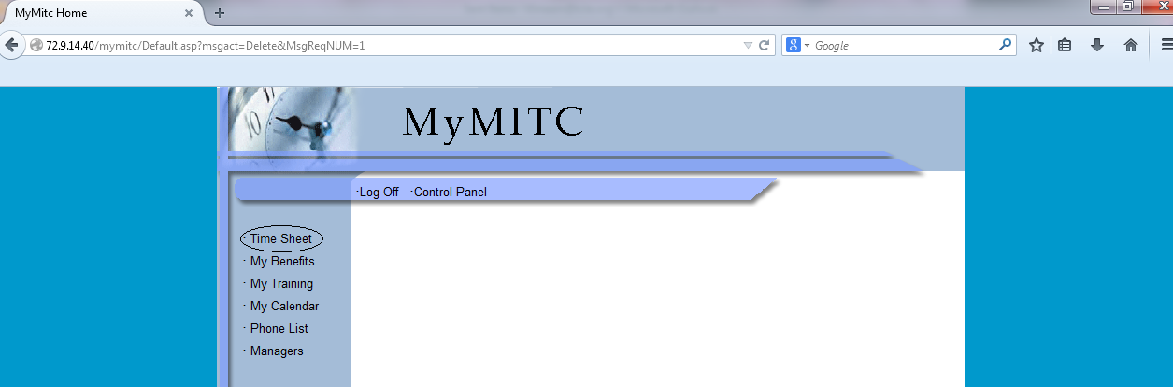
- Your time sheet will look like the image below:
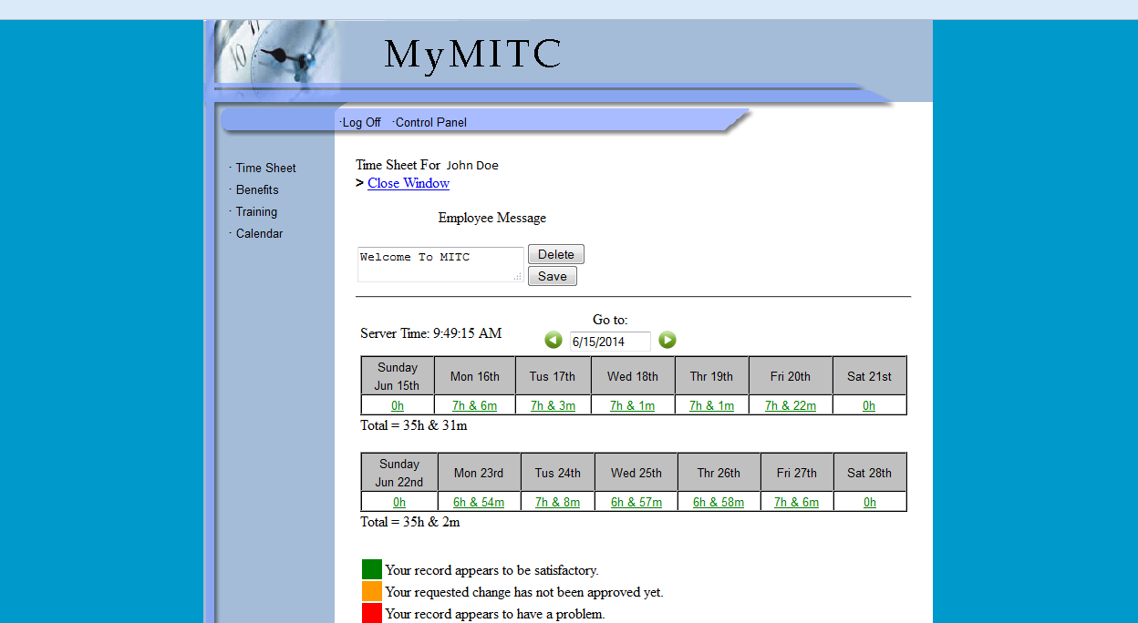

- If you are assigned multiple job codes, your time sheet will look like the image below:
- Don’t forget to read any important messages from your supervisor!
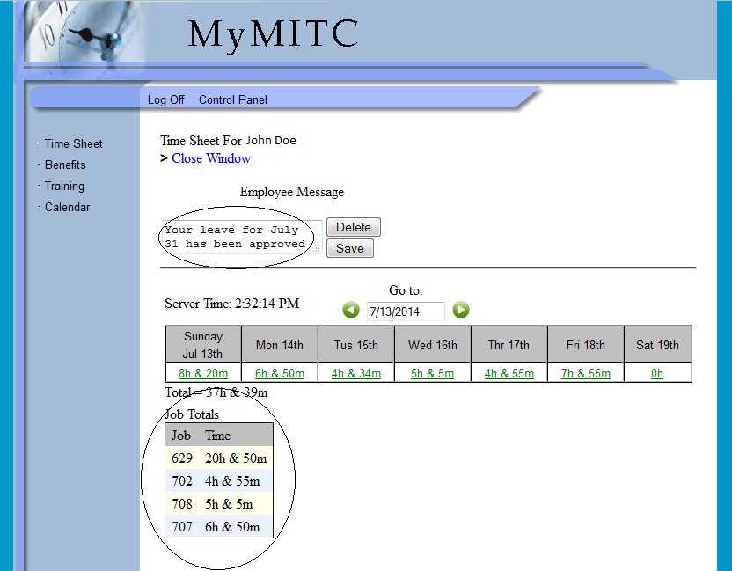

- If your record/time sheet has a problem (i.e. you forgot to clock out, etc.), your time will be displayed in red. To correct a missing punch, click on the time in red:
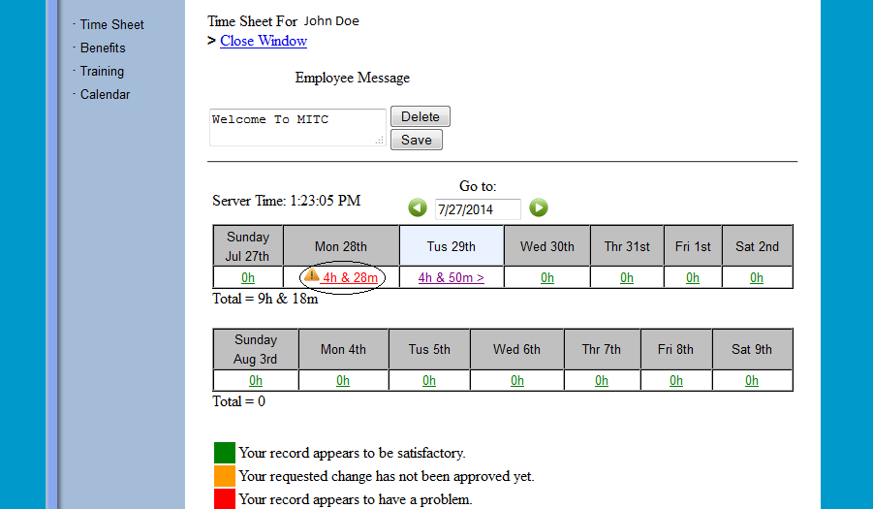
- Click on “Add an Attendance Record”
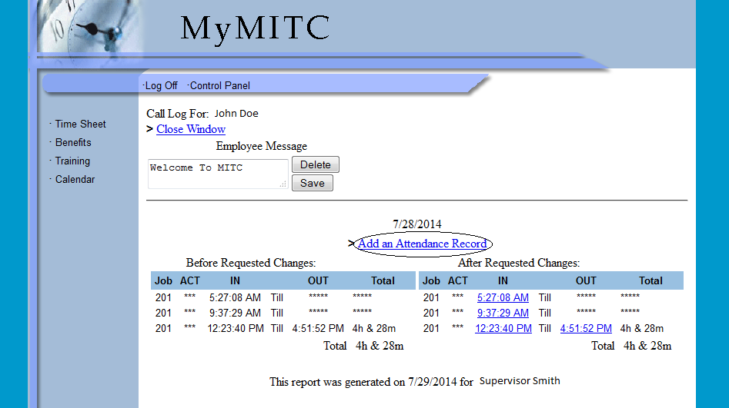

- Make the necessary adjustments to correct your time sheet; input the correct information into the following sections: “Type”, “Time”, “Job PIN #”, and “Note.” The “Note” section is an explanation to your supervisor explaining why you are adjusting your time. Once the correct information has been inputted, click Submit.
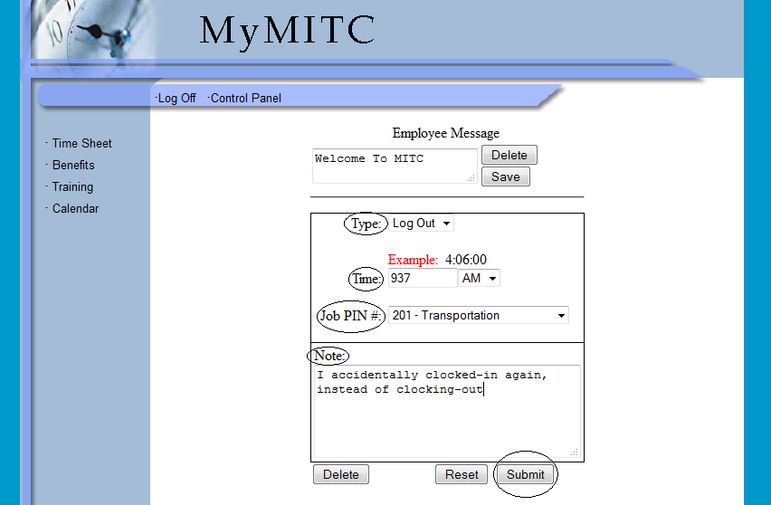

- To make adjustments to an existing punch, click on the time in red:
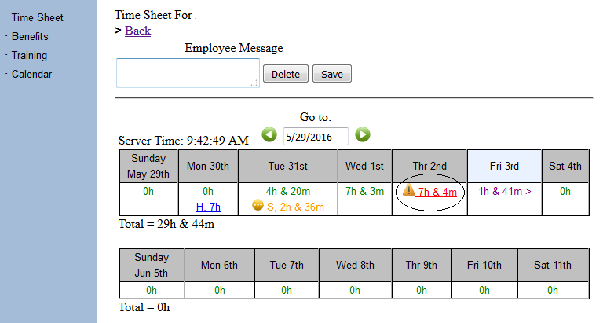
- Click on the time/punch you want to adjust or correct:
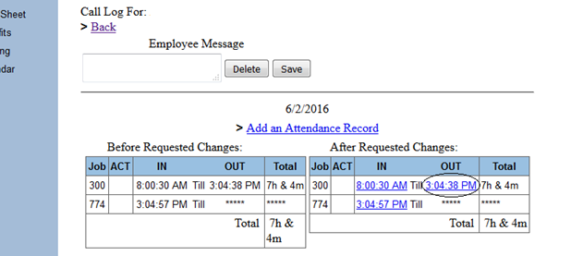
- Make the necessary adjustments to your punch. You can adjust the “Type,” “Time,” & “Job PIN.” Don’t forget to include a note! The “Note” section is an explanation to your supervisor explaining why you are adjusting your time. Once the correct information has been inputted, click Submit.

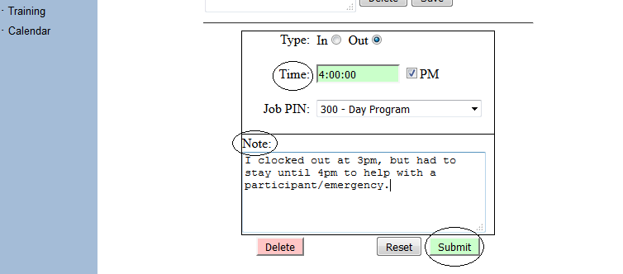

Employee Benefits

- To view your benefits (i.e. vacation, sick, & personal leave), click on “My Benefits” in the far, left-hand column

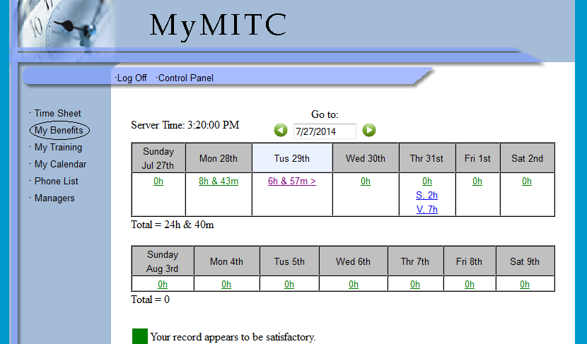

- Your benefits page will look like the image below:

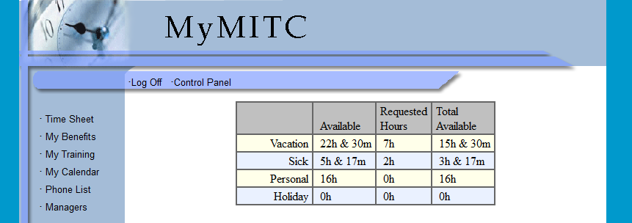

My Trainings

- To view the trainings you have completed, dates of completion, & training expiration dates, click on “My Training” in the far, left-hand column

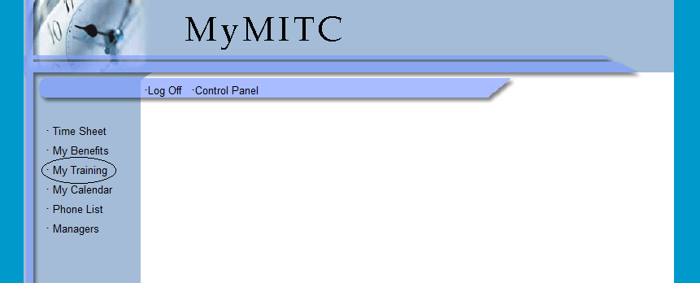

- Your training page will look like the image below. Scroll over the yellow, rectangular note with your mouse for more details; see below

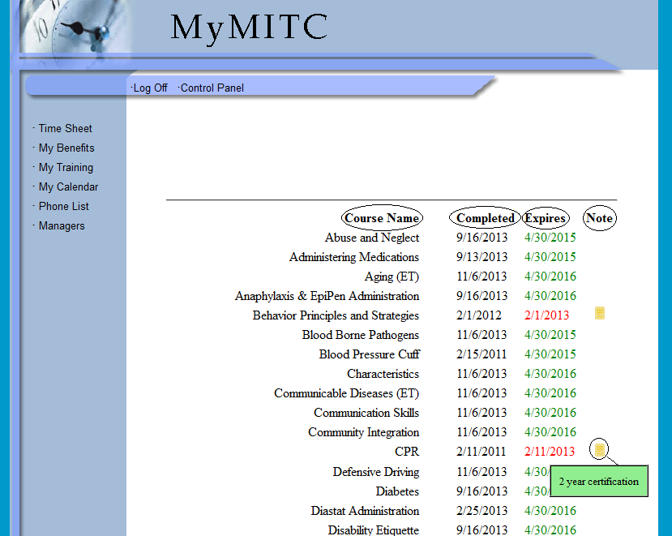

Requesting Paid Time Off/Leave on MyMITC

- All employees will use MyMITC for requesting paid time off.
- Employees requesting the use of Annual Leave/Vacation must provide your immediate supervisor at least two days’ notice. For leave requests less than two days’ notice, employees must get approval directly from your immediate supervisor/administration. In this case, the supervisor will input the leave into the MITC system and the approval will be reflected on your time sheet.
- Employees requiring time off for sick or personal leave may request time off from their immediate supervisor by contacting them directly. This is granted for employees calling-out due to an illness (sick leave) or an unexpected event (personal leave). When requesting sick leave for an upcoming doctor’s appointment or personal leave in advance, employees must use MyMITC to submit their leave request.
- With the exception of unannounced time away from work due to an illness, all sick leave should have prior approval (i.e. medical appointments, FMLA, and workers compensation claims).
- It is the responsibility of the employee to make sure that any and all leave has been approved prior to taking off.
- Immediate supervisors are required to respond to the employee’s leave request within 1 day of receipt. In the event that the immediate supervisor is absent or unable to grant the leave request, the employee requesting leave must receive approval from another administrator prior to taking leave.
- For all other forms of leave such as Funeral Leave or Jury Duty, employees must notify their immediate supervisor. Jury Duty will require documentation and in some cases Funeral Leave may need approval.

- To request leave on MyMITC, click on “My Calendar” in the far, left-hand column
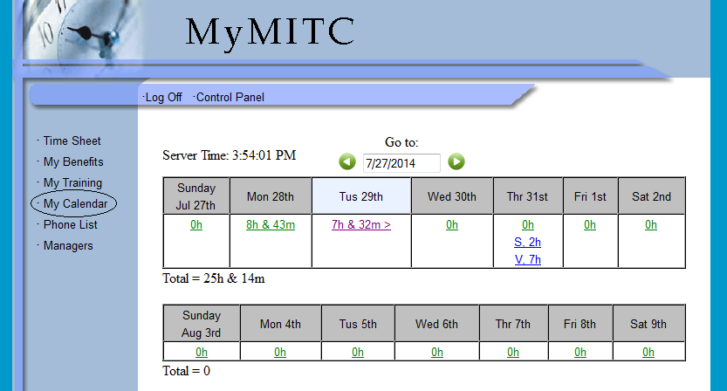

- Click on the date you are requesting leave
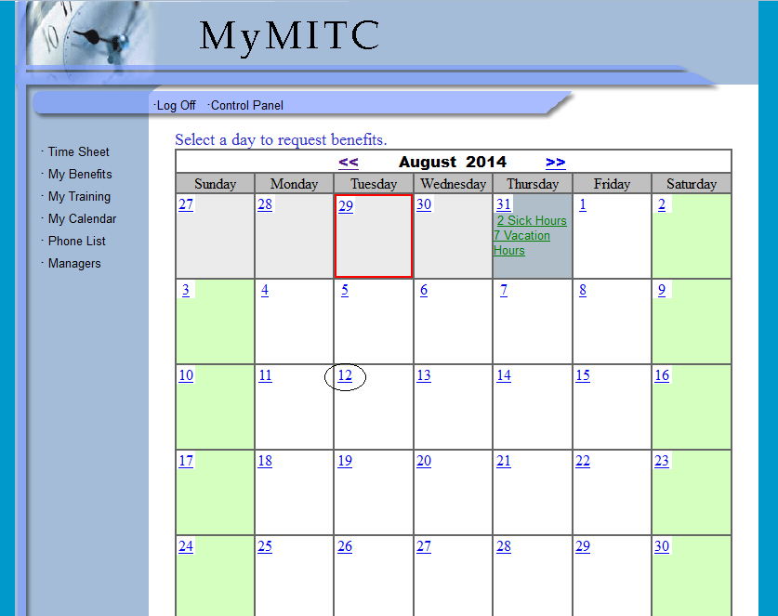
- Input leave request information into the following sections: “Type” (i.e. Annual (Vacation), Personal, Prearranged Advanced Leave Req., or Sick), “Number of hours,” and “Note.” In the “Note” section, you must provide the times you are requesting off; if you are requesting sick leave, please include a brief reason in the “Note” section as well (i.e. dental appointment for my daughter or I have a doctor’s appointment). The “Prearranged Advanced Leave Req.” option can be used to request leave in the future that you have not accrued yet. Once the information has been inputted, click Submit. Remember, employees requesting the use of Annual (Vacation) must provide your immediate supervisor at least two days’ notice. For Vacation leave requests less than two days’ notice, you must get approval directly from your immediate supervisor/administration; your supervisor will input this leave into the MITC system and the approval will be reflected on your time sheet. It is the responsibility of the employee to make sure that any and all leave has been approved prior to taking off.
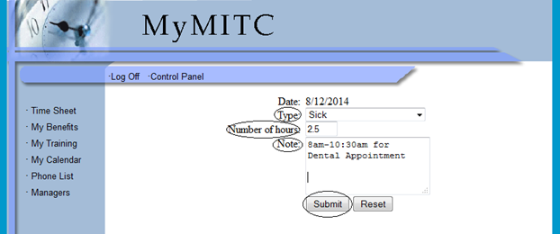

- Approved leave will be displayed in blue on your timesheet; leave that is pending/has not be approved yet will be displayed in yellow:
