Using the Z-Drive (Updated 11/16)
- To access the z-drive, click on the folder icon at the bottom of the page in the taskbar:
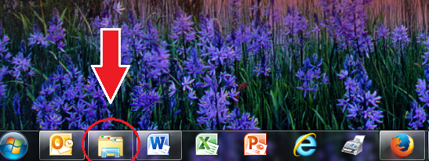
- In the left-hand column, click on the Z-drive:
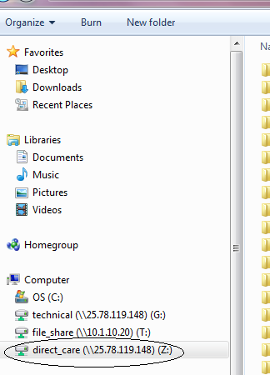
- The Z-drive contains a folder for each participant. Click on the folder you would like to view:
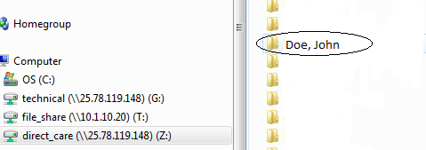
- Within each participant’s folder, there are the following folders: IP, Monthly Data, Monthly Data Templates, & Staff Training. Click on the folder you would like to view.
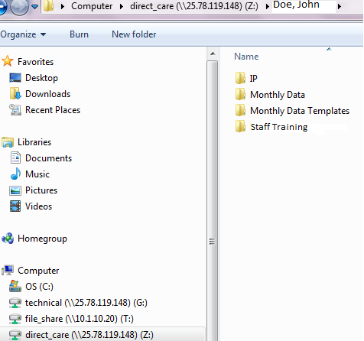
- The “IP” folder contains the current Individual Plan (IP) for the participant; the participant’s demographic information, preferences, strengths, challenges, needs, past history, & goals are documented in the Individual Plan (IP). The participant’s Behavior Management Plan (BMP) will also be saved in the IP folder and Staff Training folder, if applicable. Staff working with the participant should review the IP folder annually.

- The “Monthly Data” folder contains Monthly Reports completed by staff. Staff should save the participant’s Monthly Report(s) in the “Monthly Data” folder and update the report/record data on a daily basis.

- The participant’s blank Monthly Report or “template” can be found in the “Monthly Data Templates” folder. Staff should not type on the template. Staff should follow the steps below to “Save As”:
  - Click on the file you would like to open:
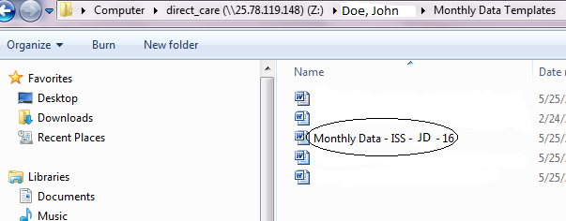
  - Click on “Enable Editing,” if prompted:
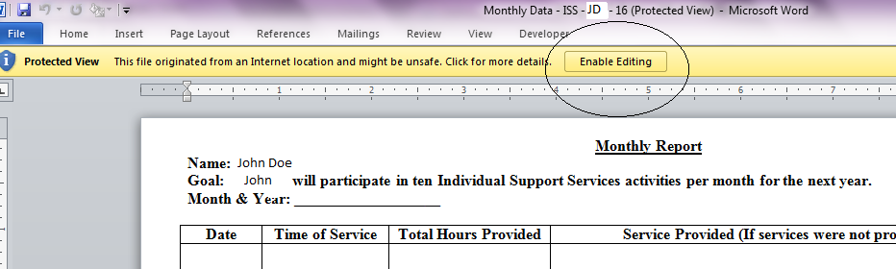

  - Click on “File”:
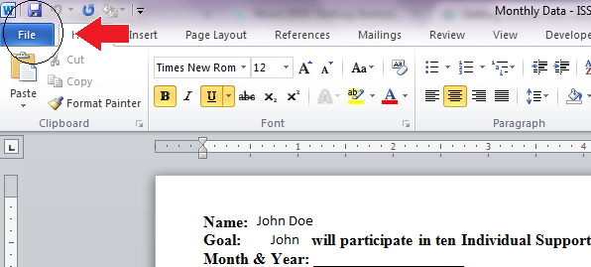

  - Click on “Save As”:
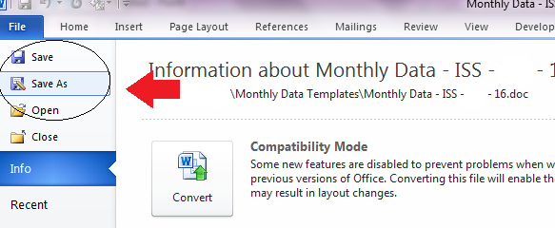

  - In the new pop-up window, click on the participant’s name to return to his/her folder on the z-drive that contains the “IP” folder, “Monthly Data” folder, “Monthly Data Template” folder, and “Participant Diagnoses” folder.
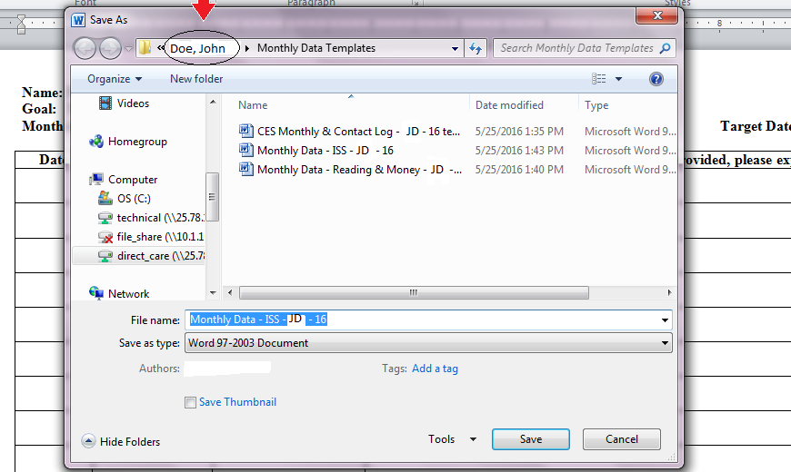

  - Click on the “Monthly Data” folder:
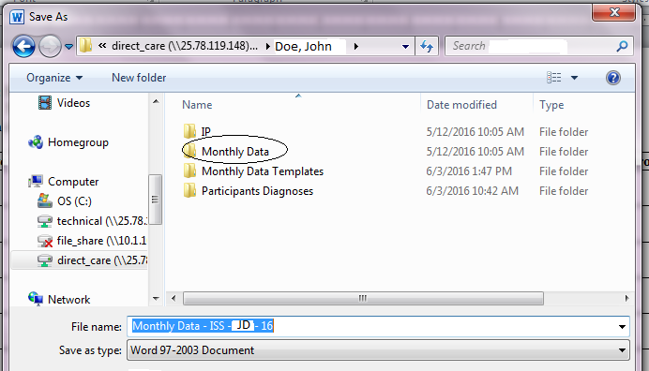

  - Change the “File Name” of the document you are saving in the “Monthly Data” folder. For example, the file name should include the type of report (Monthly Data – ISS), the participant’s initials (JD), and the month & year of the report (6-16). After changing the file name, click “Save.” The document is now saved in the “Monthly Data” folder and is ready to be typed on.

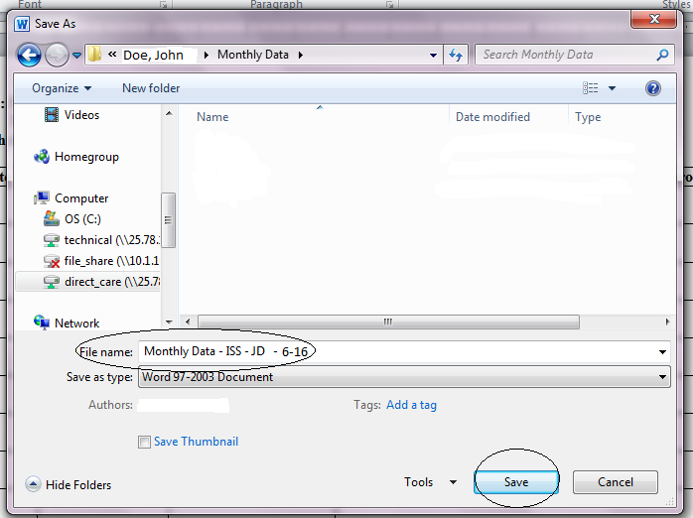

- The “Staff Training” folder on the z-drive contains information about the participant’s Behavior Management Plan (BMP), diagnoses, Nursing Care Plan (NCP), feeding protocol, seizure protocol, etc. Staff working with the participant should review the “Staff Training” folder annually and sign-off on the “Staff Training Sign-off Sheets.”
