C

Pastor Donald G. Geller, Jr.
Community United Methodist Church
Lexington Park, Maryland

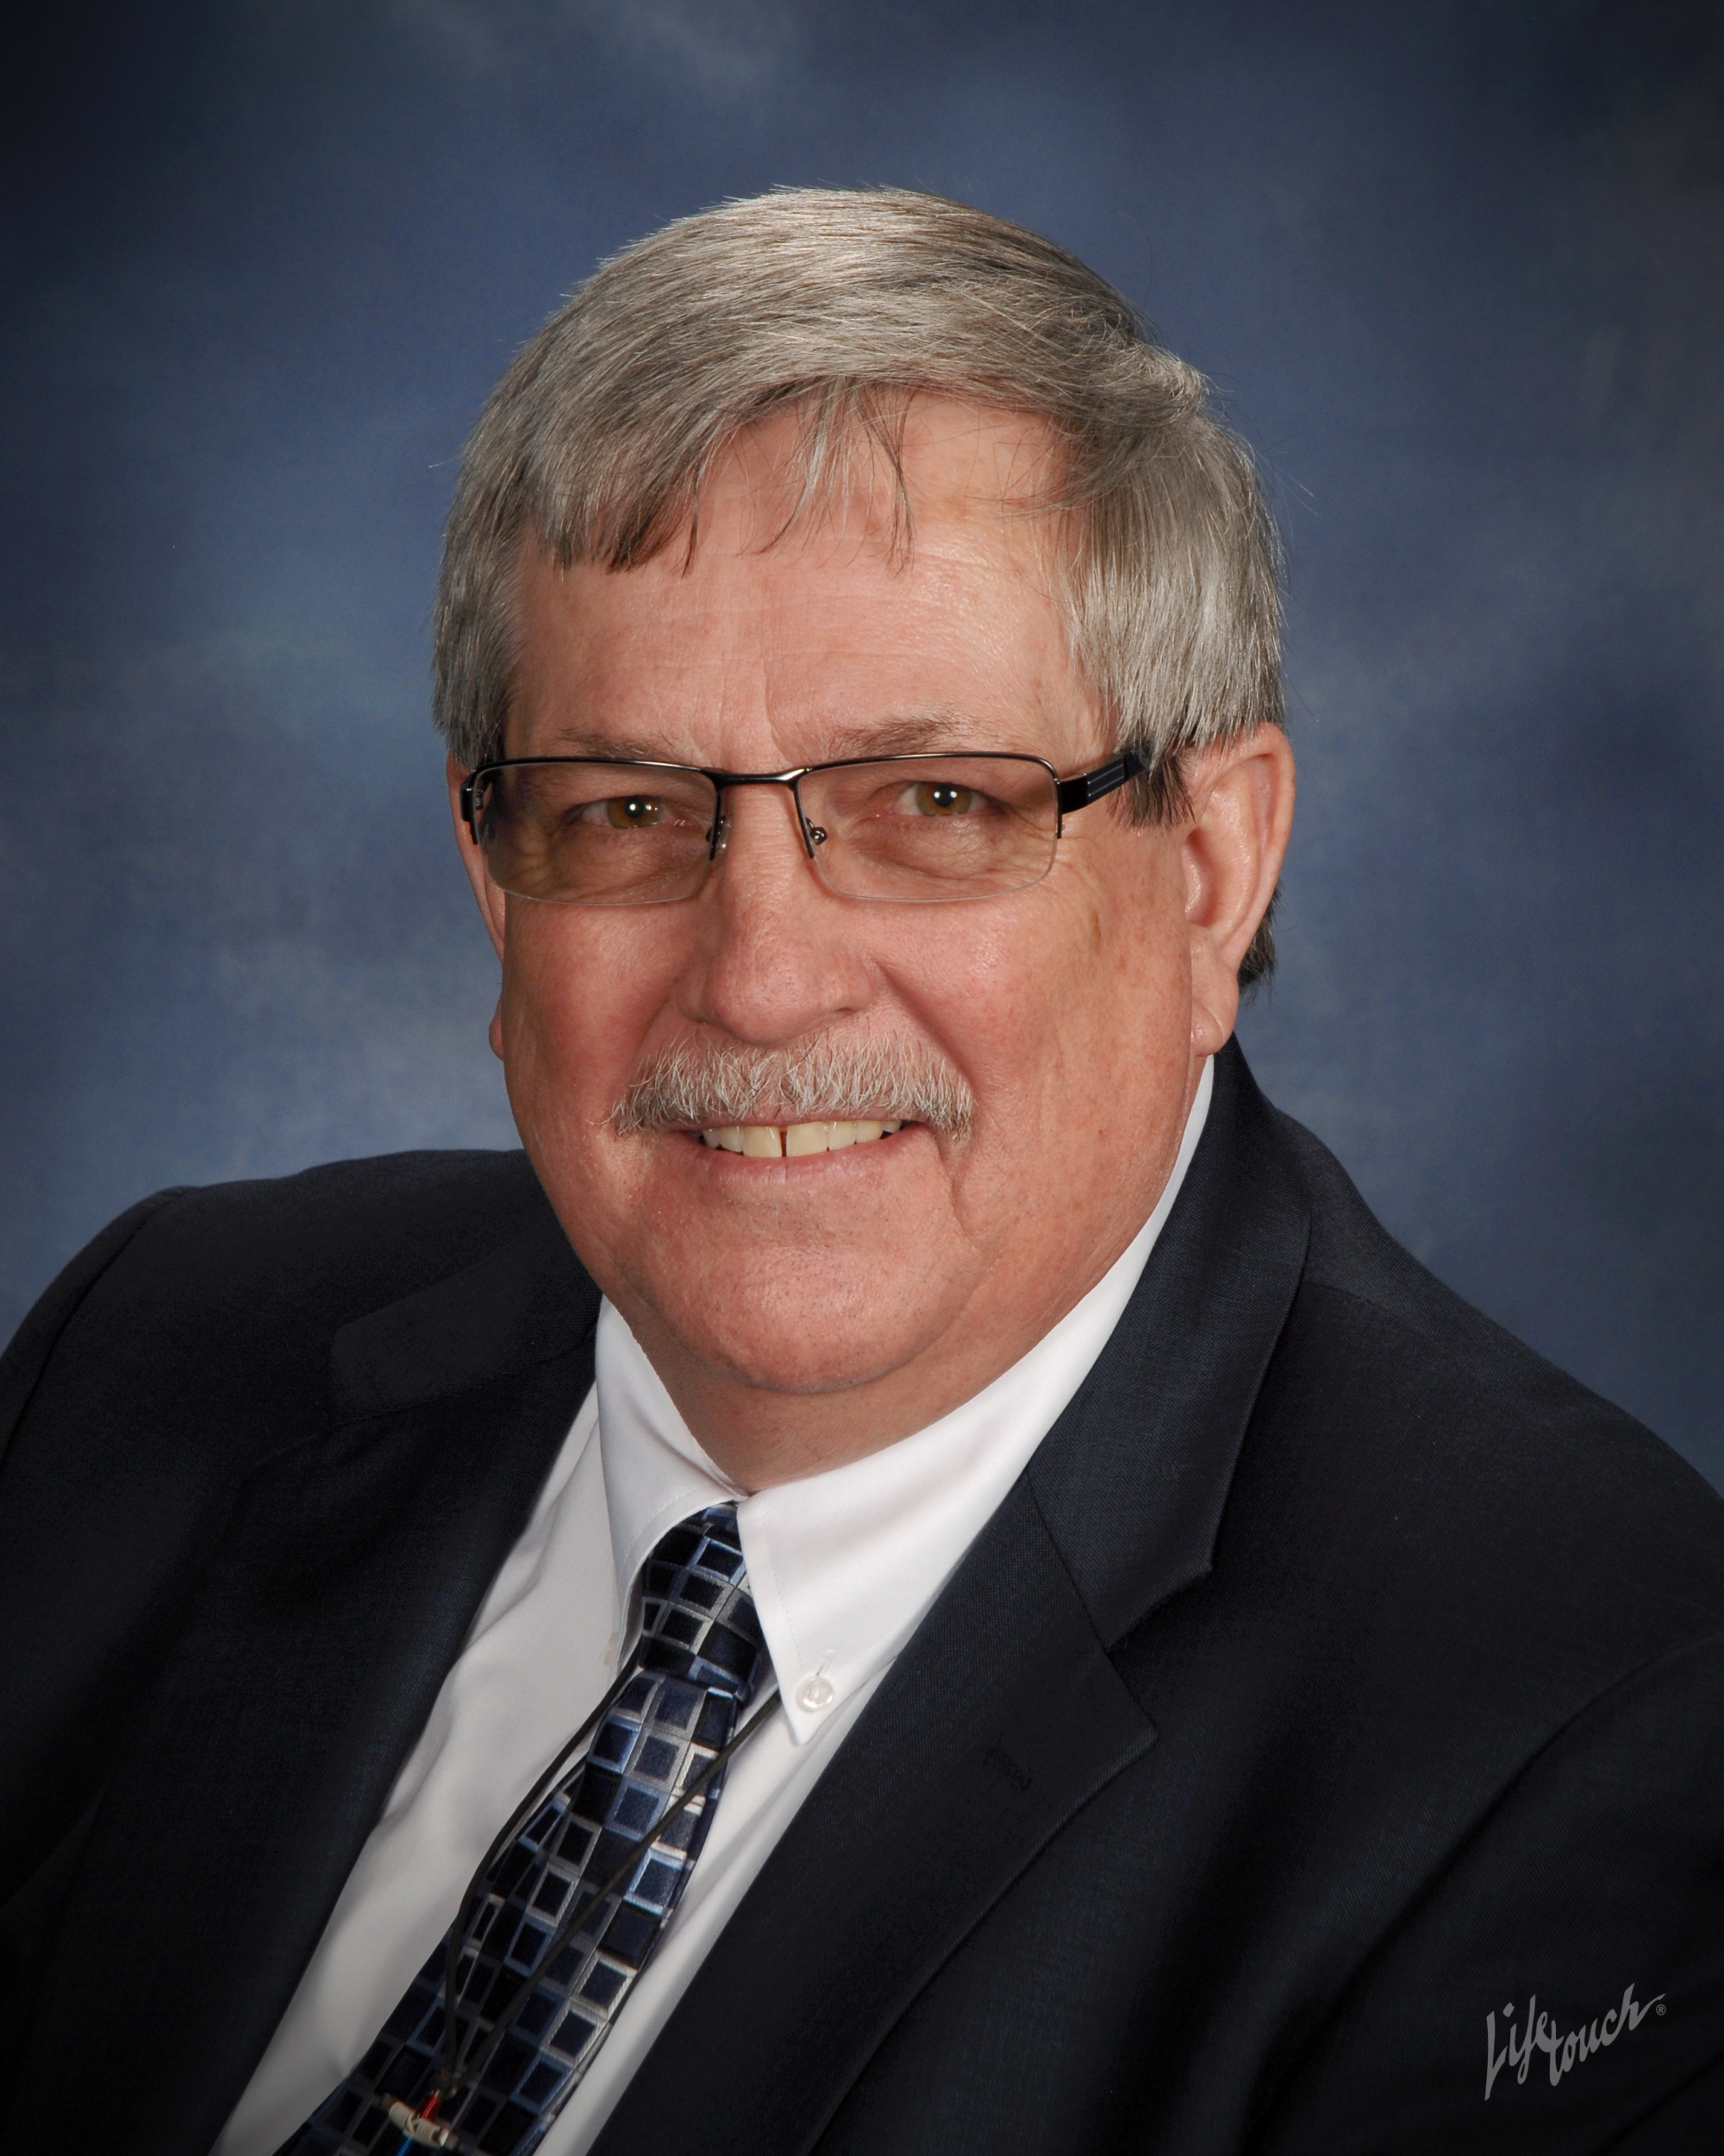

A native of Uniontown, Pennsylvania, Don’s accomplishments include a 1993 Bachelor of Science degree in Management/Computer Information Systems from Park College, a 1998 Master of Science degree in Management from Troy State University and a 2015 Master of Divinity degree from Wesley Theological Seminary.

Don was recently appointed by the Baltimore Washington Conference of the United Methodist Church to plant a new church in Lexington Park, MD to connect or reconnect families with disabled children and adults with the United Methodist Church.

Don and his wife Cindy have been married 41 years. They have 3 sons, 2 daughter-in-laws and 4 grandchildren.
Their youngest son has Cerebral Palsy and is Mentally Challenged.

We will learn to live in Community and follow the commandments we are given in Matthew 22:37-40 & Mark 12:28-34.

Through regular worship Attendance we will grow in our love for Christ and each other as children of God.
A

U
Through Understanding and acceptance we will grow as a community as we extend God’s love to each other.

The worship service will be relevant to the unique Struggles families with children and adults with disabilities face in life.
S

The worship experience will Encourage and equip everyone who attends bringing glory to God.
E

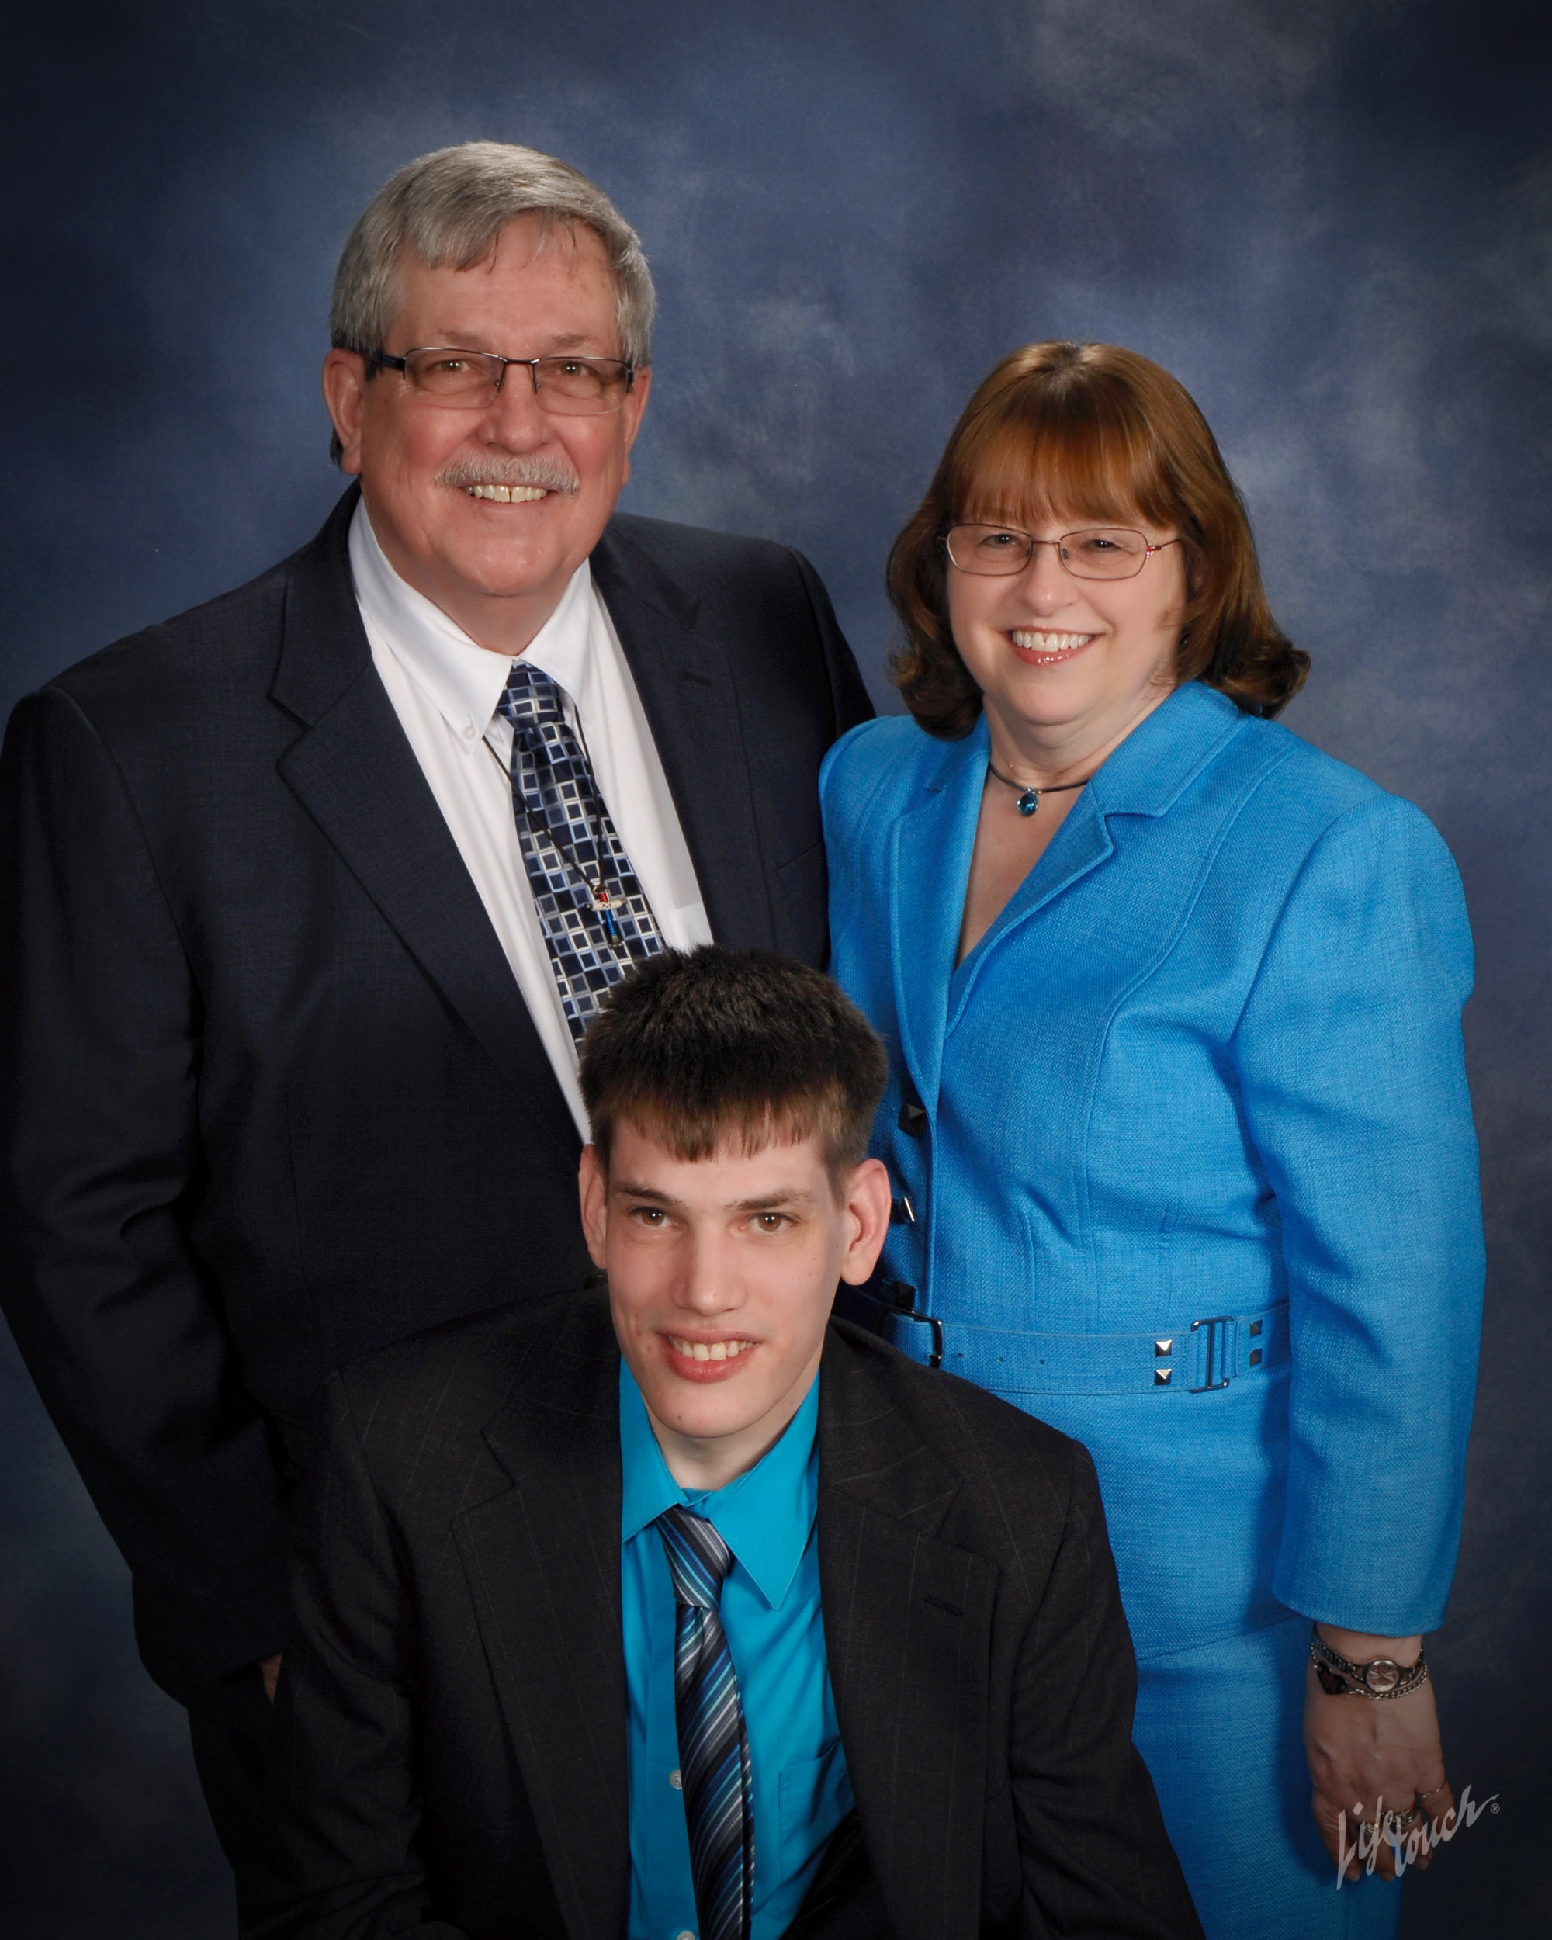

Pastor Donald G. Geller, Jr.,
wife Cindy and son Greg

Natives of Uniontown, Pennsylvania, Pastor Don and his wife Cindy have been passionate about serving the special needs community by finding and providing opportunities for Christian fellowship. Most recently, they established the Agape Club, a monthly gathering to connect individuals with disabilities with other Christ-filled community members. Through the Agape Club, they recognized the need for worship services that could best serve the families and caregivers of individuals with disabilities.
A worship service for
families and friends
of children and adults
with disabilities

Don earned his Master of Divinity degree from Wesley Theological Seminary in 2015 and was appointed by the Baltimore Washington Conference of the United Methodist Church to plant a new church in Lexington Park, MD to connect or reconnect families with children and adults with disabilities to a Christian community.

Community With A Cause

A mission congregation of the
United Methodist Church

Meets Saturday at 4 pm
Starting September 12, 2015

Website: www.community-umchurch.com
Email: pastor@community-umchurch.com

Phone: 240-434-5358
Pastor Donald G. Geller, Jr.

21760 Great Mills Road
Lexington Park, MD 20653

Worship

This new congregation is the start of a new faith community that will use unique worship services to connect or reconnect family members and caregivers of children and adults with disabilities with a Christ-centered community.

Worship Services

Saturday’s at 4:00 pm
Starting September 12, 2015
Where: Lexington Park
United Methodist Church Fellowship Hall

Other Ministries

The Agape Club
Second Friday’s at 6:00 pm

Vision

To restore hope to families and caregivers of children and adults with disabilities that God understands their struggles and has heard their prayers. That God’s love is everlasting and to reassure them that God has not forgotten them.

Mission

To provide a unique worship experience that inspires a love for Jesus and a passion for fellow human beings that transforms lives and restores hope in Jesus Christ, the Son of God.

Everyone is Welcome!

Location: Lexington Park United Methodist Church Fellowship Hall, 21760 Great Mills Road
Lexington Park, MD
